
National University of Sciences and Technology
College of Electrical and Mechanical Engineering

Path Planning for Self-Driving Vehicles using Deep
Reinforcement Learning
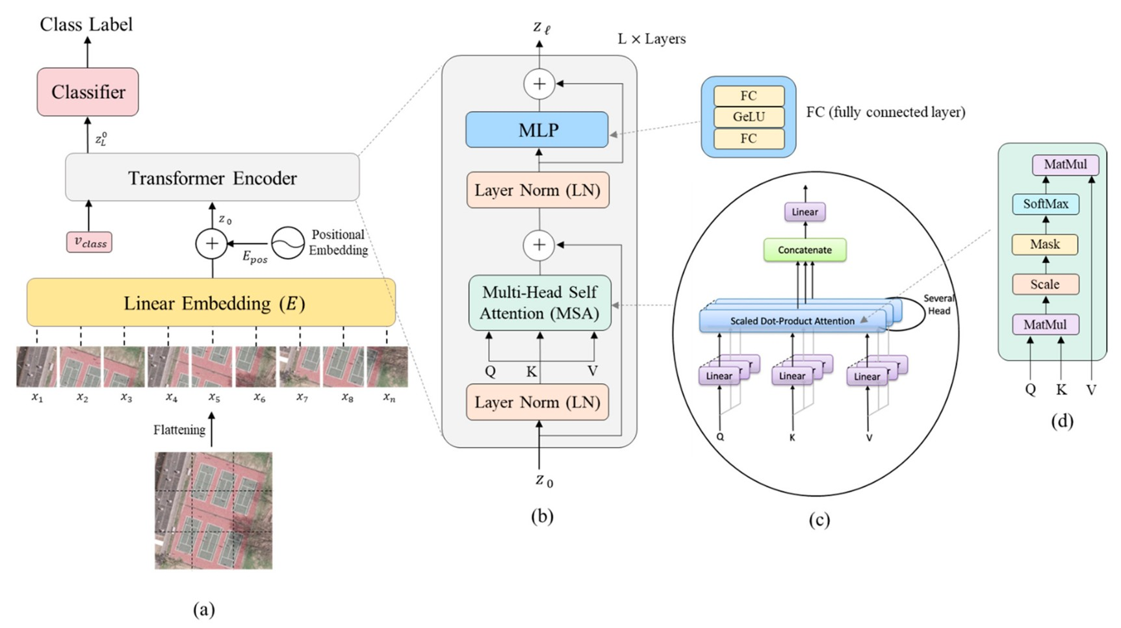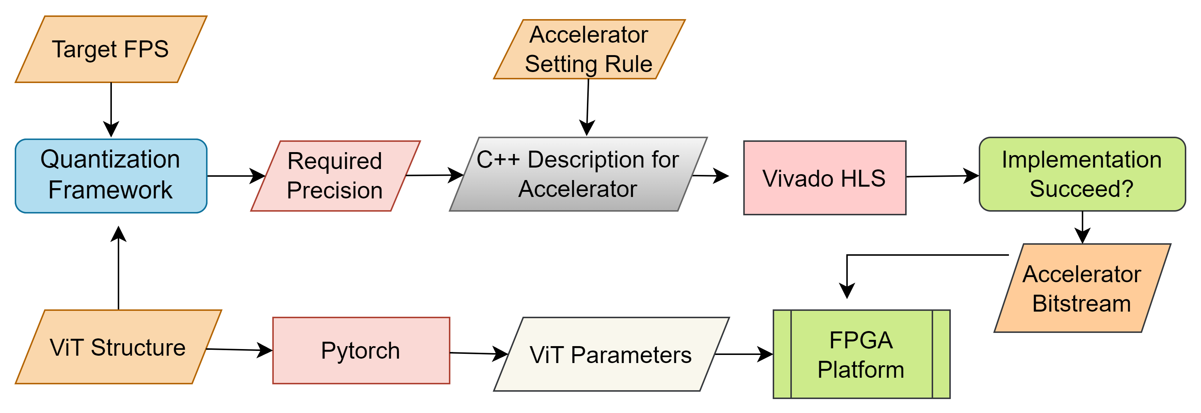
DDPG Architecture

Work Flow Structure

Challenges
- Implementation of multiple modules not available in Brevitas and Finn HLS.
- Model compression while maintaining the best accuracy and finding optimum bit-width for each layer.
- Finding alternatives for some operations that are predominantly sequential, which can impede pipeline efficiency

Conclusion
Vision transformers on FPGA will revolutionize computer vision by enabling real-time, energy- efficient image analysis, transforming industries like autonomous vehicles and healthcare, and fostering innovation and breakthroughs.
FYP Supervisor: Dr Faisal Shafait Co-Advisor: Dr Adnan-ul-Hassan
Team Members: Talha Israr, Rakhmeen Gul, Muhammad Hamza Javaid
Problem Statement
The self-driving vehicles required huge amount of dataset which increases cost as well time to preprocess the dataset. An efficient way is to use a simulator with
The advent of Vision Transformers (ViTs) has advanced accuracy in computer vision tasks. However, their intricate architecture, substantial computational and storage demands, large number of parameters, complex design (mainly
Methodology

Our proposed solution is to use deep reinforcement learning algorithms and train them on a simulator to train the model for any possible scenario like collision with pedestrians without harming any human kind and to reduce cost of operating real vehicles and generating critical scenarios


Tools and Acknowledgments

